**Certificate from Completion**

**of Industrial Training**

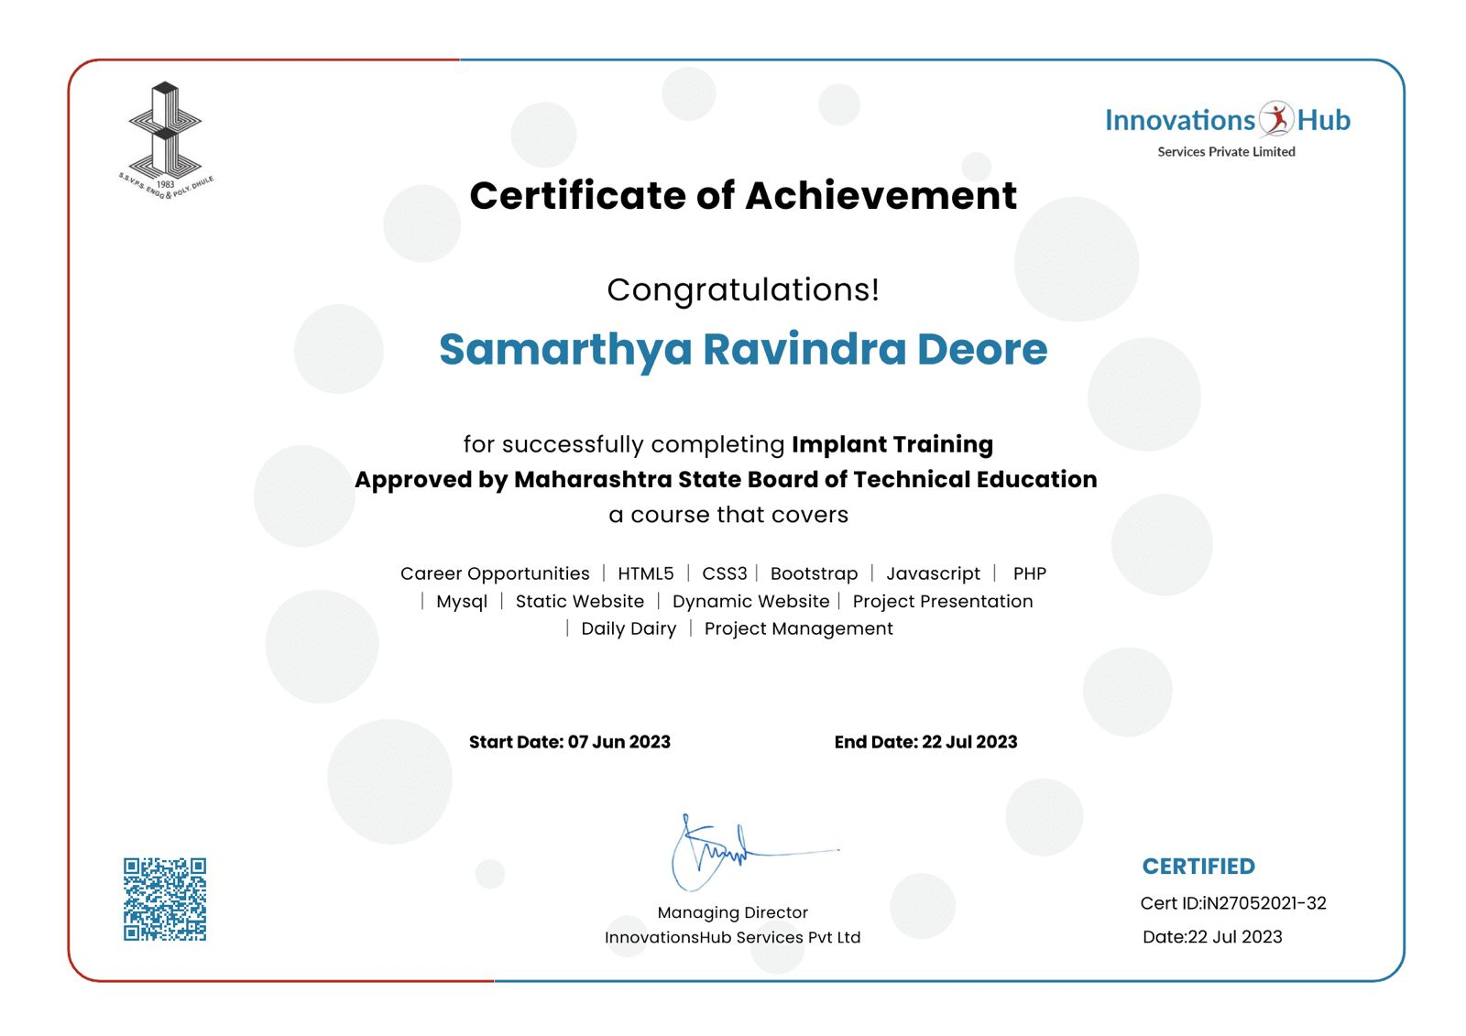

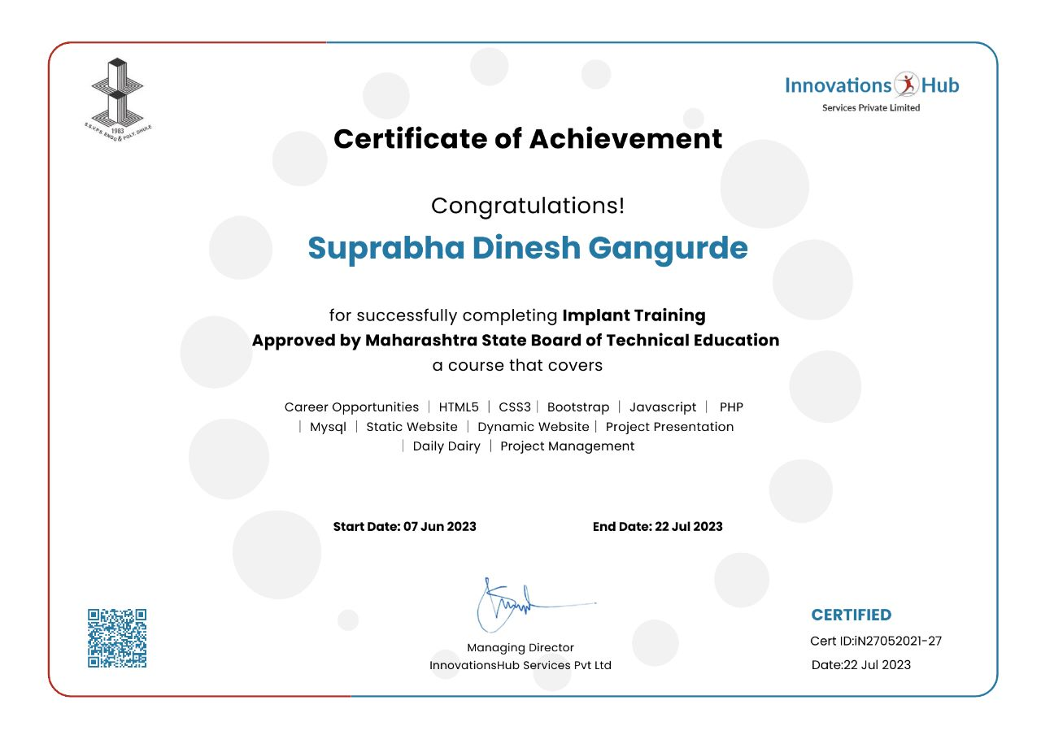

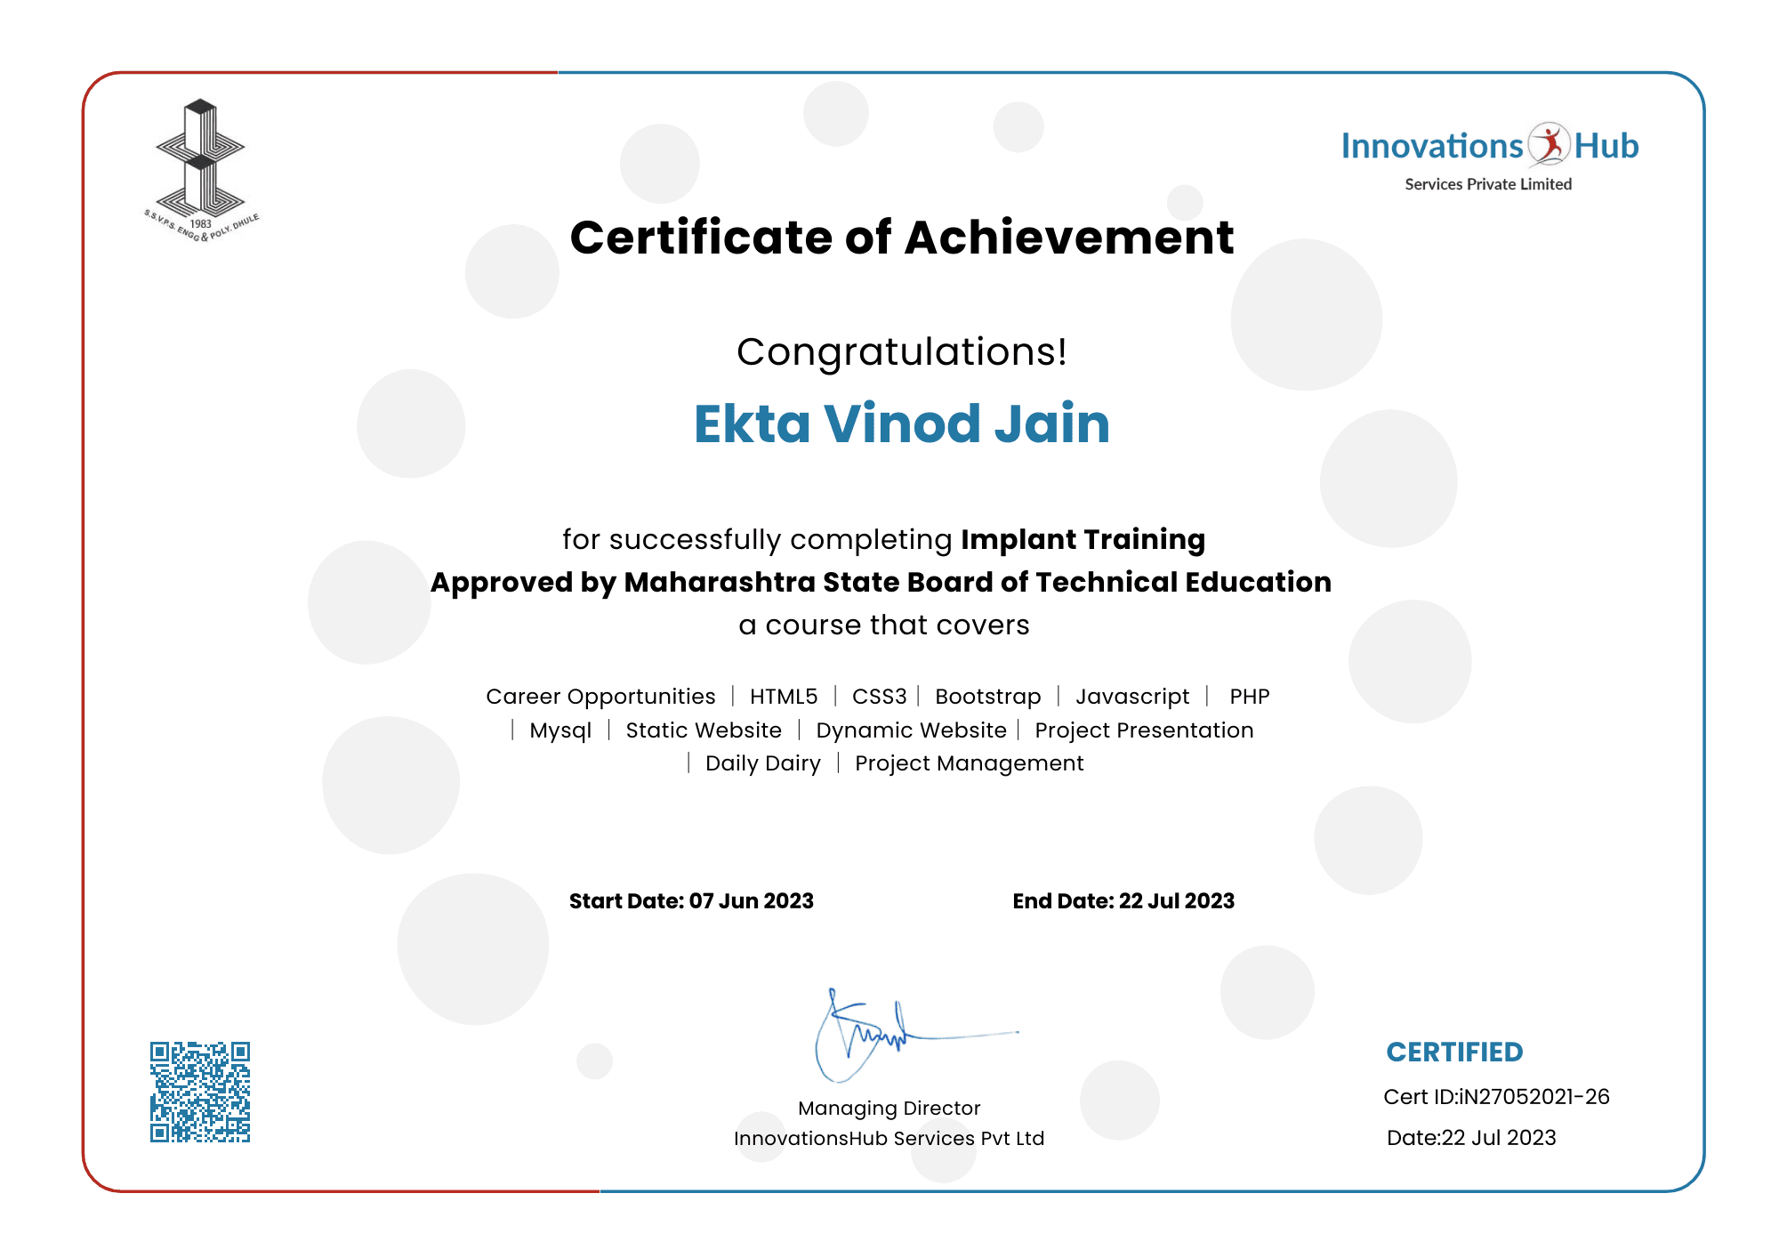

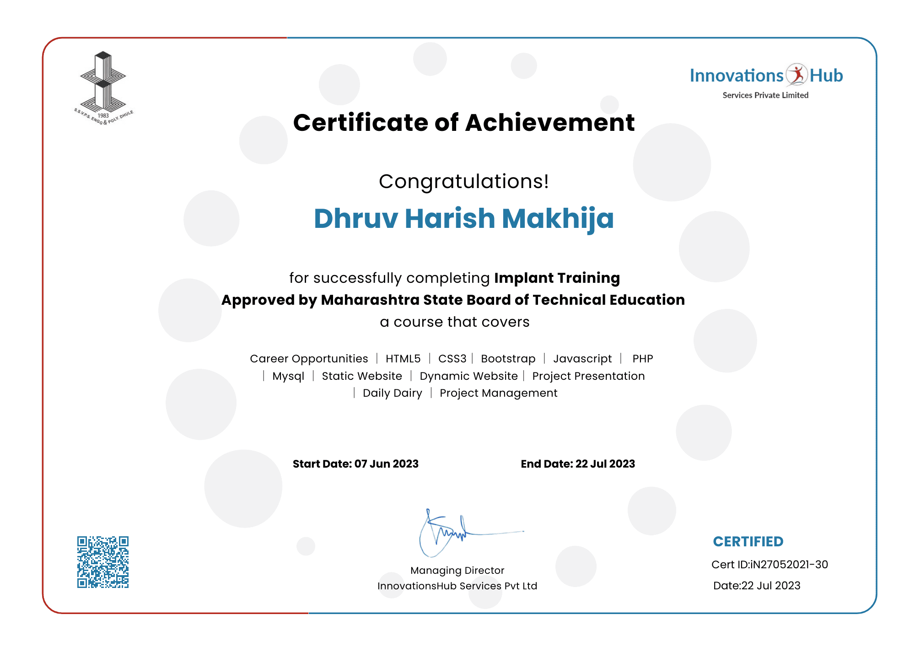

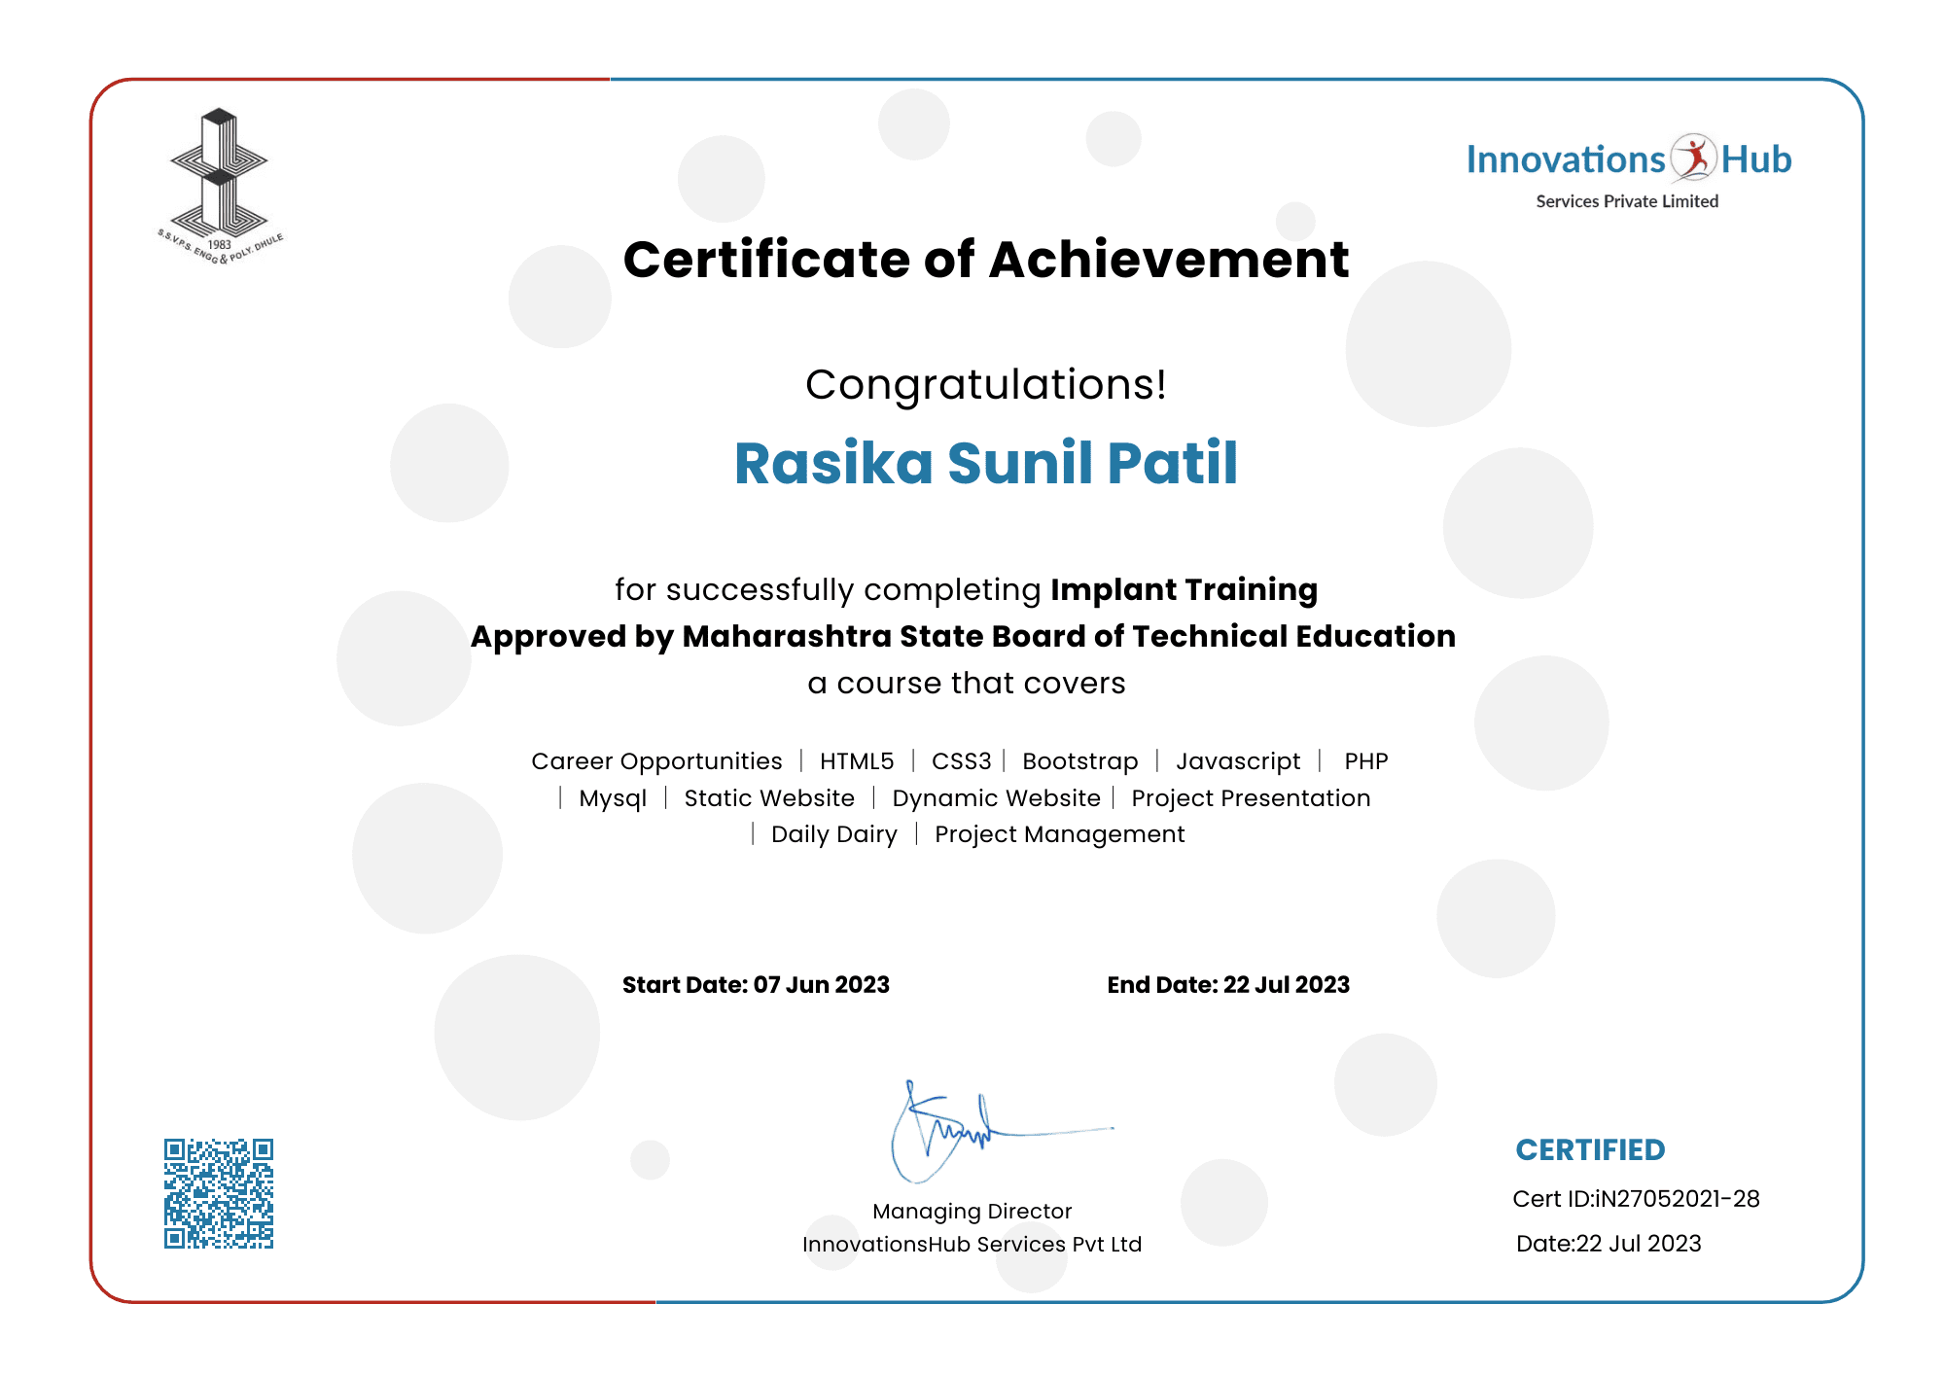

**Abstract**

This abstract presents a dynamic shoe website developed using a robust stack of technologies including HTML, CSS, Bootstrap, JavaScript, and PHP. The website features an interactive admin panel, a user panel, as well as efficient login and sign-up forms to enhance the overall user experience.

The website's core design principles revolve around providing a seamless and visually appealing interface, ensuring easy navigation, and facilitating efficient management of both user and product data. The frontend of the website has been crafted using HTML, CSS, and Bootstrap, resulting in a responsive design that adapts to various screen sizes, from desktops to mobile devices. The website's login and sign-up forms are equipped with robust authentication mechanisms, protecting user data and safeguarding against unauthorized access using JavaScript. This security measure enhances user confidence and trust in the platform. In conclusion, this dynamic shoe website showcases the seamless integration of HTML, CSS, Bootstrap, JavaScript, and PHP, resulting in an engaging and user-friendly footwear shopping platform. The incorporation of an admin panel and a user panel, along with secure login and sign-up forms, sets the stage for an e-commerce venture, providing customers with a delightful shopping experience while empowering administrators with the tools to manage the platform efficiently.

**Acknowledgment**

We hereby take this opportunity to express our gratitude towards the people whose help is very useful in completing our project “E-Shop (Footwear Website)”. We would like to thank our guide, Mr. C. P. Bhamare, whose guidance became very valuable to us. We are also very thankful to our head of department, Ms. S. H. Patil for providing precious help and advice. Finally, we would like to thank all our friends and well-wishers who are very important in nurturing and strengthening our careers.

**Yours Sincerely,**

1) Deore Samarthya Ravindra

2) Gangurde Suprabha Dinesh

3) Jain Ekta Vinod

4) Makhija Dhruv Harish

5) Patil Rasika Sunil